JAVA PROGRAMMING – LAB PROGRAMS
Programs 1–10
PROGRAM 1 – APPLET: DISPLAY NAME, ROLL NUMBER AND COURSE
import java.applet.Applet;
import java.awt.*;
public class Main extends Applet
{
public void paint(Graphics g)
{
g.setColor(Color.RED);
g.setFont(new Font("Arial", Font.BOLD, 20));
g.drawString("Name: Bhargav Reddy", 50, 50);
g.setColor(Color.BLUE);
g.setFont(new Font("Arial", Font.ITALIC, 20));
g.drawString("Roll Number: 12345", 50, 100);
g.setColor(Color.GREEN);
g.setFont(new Font("Arial", Font.PLAIN, 20));
g.drawString("Course: Cyber Security", 50, 150);
}
}
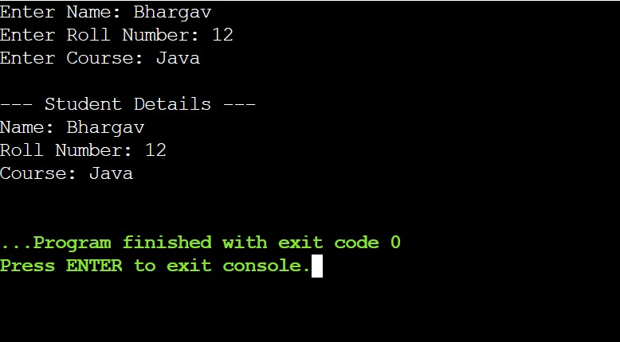
PROGRAM 2A – STAND-ALONE APPLET
import java.applet.Applet;
import java.awt.*;
public class Main extends Applet
{
public void paint(Graphics g)
{
g.drawString("This is a Stand-alone Applet", 50, 100);
}
}

PROGRAM 2B – HTML EMBEDDED APPLET
import java.applet.Applet;
import java.awt.*;
public class Main extends Applet
{
public void paint(Graphics g)
{
g.drawString("This is an HTML Embedded Applet", 50, 100);
}
}
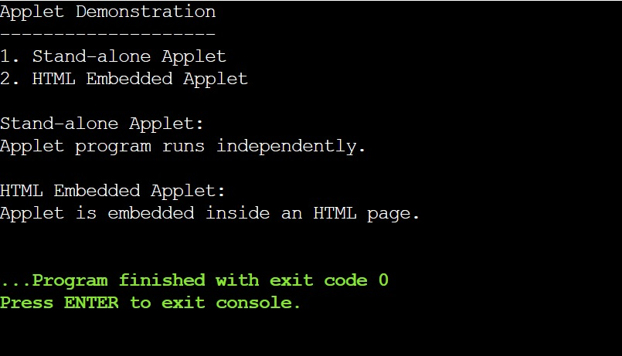
PROGRAM 3 – APPLET TO FIND SQUARE OF A NUMBER
import java.applet.Applet;
import java.awt.*;
import java.awt.event.*;
public class Main extends Applet implements ActionListener
{
TextField t;
Button b;
Label result;
public void init()
{
t = new TextField(10);
b = new Button("Square");
result = new Label();
add(new Label("Enter number:"));
add(t);
add(b);
add(result);
b.addActionListener(this);
}
public void actionPerformed(ActionEvent e)
{
int n = Integer.parseInt(t.getText());
int square = n * n;
result.setText("Square = " + square);
}
}
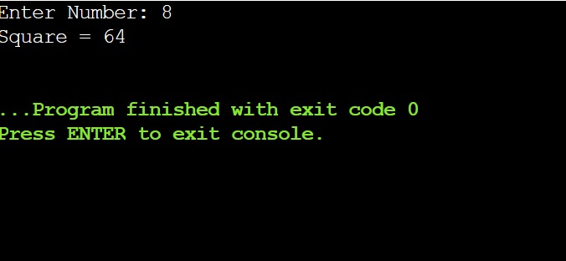
PROGRAM 4 – FLOWLAYOUT, BORDERLAYOUT AND GRIDLAYOUT
import javax.swing.*;
import java.awt.*;
public class Main
{
public static void main(String[] args)
{
JFrame f = new JFrame("Layout Manager");
f.setLayout(new FlowLayout());
JButton b1 = new JButton("FlowLayout");
JButton b2 = new JButton("BorderLayout");
JButton b3 = new JButton("GridLayout");
f.add(b1);
f.add(b2);
f.add(b3);
f.setSize(400, 200);
f.setDefaultCloseOperation(JFrame.EXIT_ON_CLOSE);
f.setVisible(true);
}
}
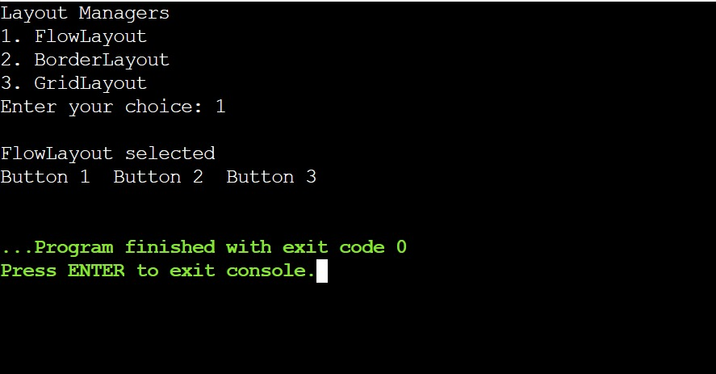
PROGRAM 5 – AWT REGISTRATION FORM
import java.awt.*;
import java.awt.event.*;
public class Main extends Frame implements ActionListener
{
TextField name, age;
Checkbox male, female;
Choice course;
Button submit;
Label result;
Main()
{
setLayout(new FlowLayout());
add(new Label("Name:"));
name = new TextField(20);
add(name);
add(new Label("Age:"));
age = new TextField(5);
add(age);
add(new Label("Gender:"));
male = new Checkbox("Male");
female = new Checkbox("Female");
add(male);
add(female);
add(new Label("Course:"));
course = new Choice();
course.add("Cyber Security");
course.add("Computer Science");
course.add("Information Technology");
add(course);
submit = new Button("Submit");
add(submit);
result = new Label();
add(result);
submit.addActionListener(this);
setTitle("Registration Form");
setSize(500, 300);
setVisible(true);
}
public void actionPerformed(ActionEvent e)
{
String gender = "";
if (male.getState())
gender = "Male";
else if (female.getState())
gender = "Female";
result.setText("Name: " + name.getText()
+ " Age: " + age.getText()
+ " Gender: " + gender
+ " Course: " + course.getSelectedItem());
}
public static void main(String[] args)
{
new Main();
}
}
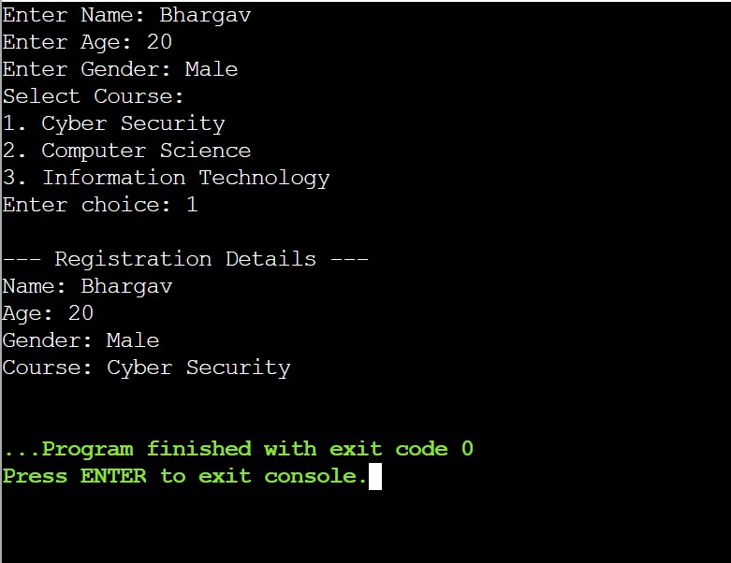
PROGRAM 6 – DELEGATION EVENT MODEL: ACTIONEVENT AND ITEMEVENT
import java.awt.*;
import java.awt.event.*;
public class Main extends Frame
implements ActionListener, ItemListener
{
Button button;
Checkbox checkbox;
Label result;
Main()
{
setLayout(new FlowLayout());
button = new Button("Click Me");
checkbox = new Checkbox("Java");
result = new Label("Event will appear here");
add(button);
add(checkbox);
add(result);
button.addActionListener(this);
checkbox.addItemListener(this);
setTitle("Event Handling");
setSize(400, 200);
setVisible(true);
}
public void actionPerformed(ActionEvent e)
{
result.setText("ActionEvent occurred");
}
public void itemStateChanged(ItemEvent e)
{
result.setText("ItemEvent occurred");
}
public static void main(String[] args)
{
new Main();
}
}
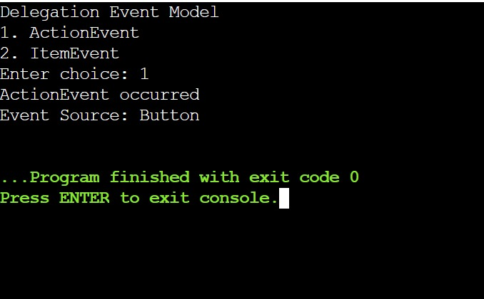
PROGRAM 7 – DIFFERENT SOURCES OF EVENTS
import java.awt.*;
import java.awt.event.*;
public class Main extends Frame
implements ActionListener, ItemListener,
TextListener, WindowListener
{
Button button;
TextField text;
Checkbox checkbox;
Label result;
Main()
{
setLayout(new FlowLayout());
button = new Button("Click");
text = new TextField(20);
checkbox = new Checkbox("Java");
result = new Label("Event:");
add(button);
add(text);
add(checkbox);
add(result);
button.addActionListener(this);
text.addTextListener(this);
checkbox.addItemListener(this);
addWindowListener(this);
setTitle("Event Sources");
setSize(500, 250);
setVisible(true);
}
public void actionPerformed(ActionEvent e)
{
result.setText("Source: Button | Type: ActionEvent");
}
public void textValueChanged(TextEvent e)
{
result.setText("Source: TextField | Type: TextEvent");
}
public void itemStateChanged(ItemEvent e)
{
result.setText("Source: Checkbox | Type: ItemEvent");
}
public void windowClosing(WindowEvent e)
{
result.setText("Source: Window | Type: WindowEvent");
System.exit(0);
}
public void windowOpened(WindowEvent e) {}
public void windowClosed(WindowEvent e) {}
public void windowIconified(WindowEvent e) {}
public void windowDeiconified(WindowEvent e) {}
public void windowActivated(WindowEvent e) {}
public void windowDeactivated(WindowEvent e) {}
public static void main(String[] args)
{
new Main();
}
}
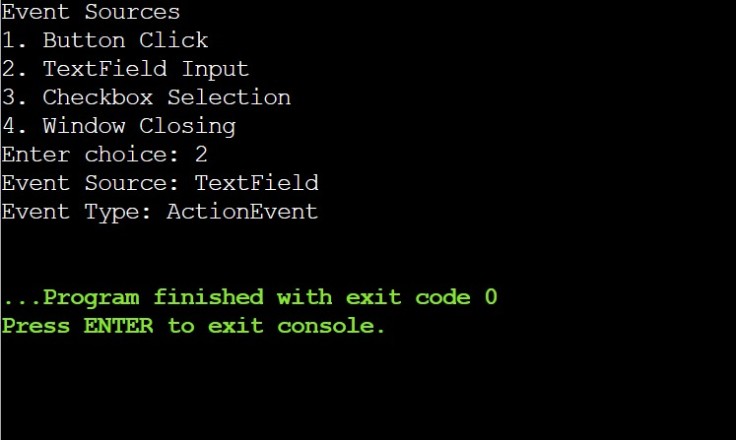PROGRAM 8 – SWING MENU-DRIVEN CALCULATOR
import javax.swing.*;
import java.awt.*;
import java.awt.event.*;
public class Main extends JFrame implements ActionListener
{
JTextField n1, n2, result;
JMenuItem add, sub, mul, div, clear, exit;
Main()
{
setLayout(new FlowLayout());
n1 = new JTextField(10);
n2 = new JTextField(10);
result = new JTextField(10);
add(new JLabel("Number 1:"));
add(n1);
add(new JLabel("Number 2:"));
add(n2);
add(new JLabel("Result:"));
add(result);
JMenuBar bar = new JMenuBar();
JMenu menu = new JMenu("Calculator");
add = new JMenuItem("Add");
sub = new JMenuItem("Subtract");
mul = new JMenuItem("Multiply");
div = new JMenuItem("Divide");
clear = new JMenuItem("Clear");
exit = new JMenuItem("Exit");
menu.add(add);
menu.add(sub);
menu.add(mul);
menu.add(div);
menu.add(clear);
menu.add(exit);
bar.add(menu);
setJMenuBar(bar);
add.addActionListener(this);
sub.addActionListener(this);
mul.addActionListener(this);
div.addActionListener(this);
clear.addActionListener(this);
exit.addActionListener(this);
setTitle("Menu Calculator");
setSize(400, 250);
setDefaultCloseOperation(JFrame.EXIT_ON_CLOSE);
setVisible(true);
}
public void actionPerformed(ActionEvent e)
{
if (e.getSource() == clear)
{
n1.setText("");
n2.setText("");
result.setText("");
}
else if (e.getSource() == exit)
{
System.exit(0);
}
else
{
double a = Double.parseDouble(n1.getText());
double b = Double.parseDouble(n2.getText());
double r = 0;
if (e.getSource() == add)
r = a + b;
else if (e.getSource() == sub)
r = a - b;
else if (e.getSource() == mul)
r = a * b;
else if (e.getSource() == div)
r = a / b;
result.setText(String.valueOf(r));
}
}
public static void main(String[] args)
{
new Main();
}
}
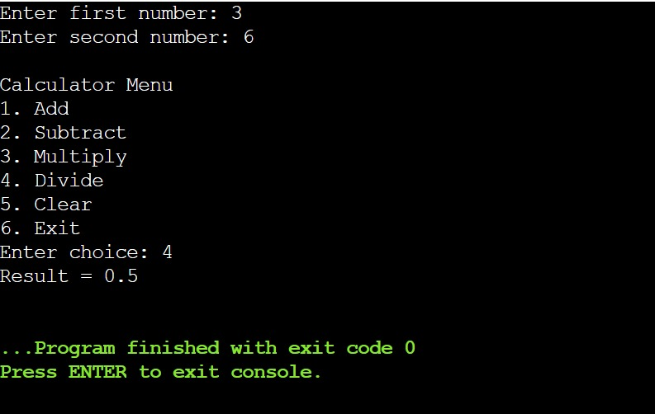PROGRAM 9 – APPLET: DRAW LINE, RECTANGLE, OVAL AND CHANGE COLOR
import java.applet.Applet;
import java.awt.*;
import java.awt.event.*;
public class Main extends Applet implements ItemListener
{
Choice shape, color;
public void init()
{
shape = new Choice();
shape.add("Line");
shape.add("Rectangle");
shape.add("Oval");
color = new Choice();
color.add("Red");
color.add("Blue");
color.add("Green");
add(new Label("Shape:"));
add(shape);
add(new Label("Color:"));
add(color);
shape.addItemListener(this);
color.addItemListener(this);
}
public void itemStateChanged(ItemEvent e)
{
repaint();
}
public void paint(Graphics g)
{
if (color.getSelectedItem().equals("Red"))
g.setColor(Color.RED);
else if (color.getSelectedItem().equals("Blue"))
g.setColor(Color.BLUE);
else
g.setColor(Color.GREEN);
String s = shape.getSelectedItem();
if (s.equals("Line"))
g.drawLine(100, 150, 300, 150);
else if (s.equals("Rectangle"))
g.drawRect(100, 100, 200, 100);
else
g.drawOval(100, 100, 200, 100);
}
}
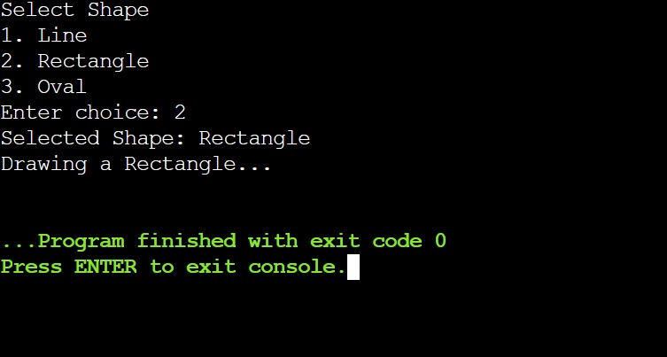PROGRAM 10 – STUDENT RECORD GUI: ADD, UPDATE, DELETE AND DISPLAY
import javax.swing.*;
import java.awt.*;
import java.awt.event.*;
public class Main extends JFrame implements ActionListener
{
JTextField id, name, marks;
JTextArea display;
JButton add, update, delete, show;
String studentId = "";
String studentName = "";
String studentMarks = "";
Main()
{
setLayout(new FlowLayout());
add(new JLabel("Student ID:"));
id = new JTextField(15);
add(id);
add(new JLabel("Name:"));
name = new JTextField(15);
add(name);
add(new JLabel("Marks:"));
marks = new JTextField(15);
add(marks);
add = new JButton("Add");
update = new JButton("Update");
delete = new JButton("Delete");
show = new JButton("Display");
add(add);
add(update);
add(delete);
add(show);
display = new JTextArea(8, 30);
add(display);
add.addActionListener(this);
update.addActionListener(this);
delete.addActionListener(this);
show.addActionListener(this);
setTitle("Student Record");
setSize(450, 400);
setDefaultCloseOperation(JFrame.EXIT_ON_CLOSE);
setVisible(true);
}
public void actionPerformed(ActionEvent e)
{
if (e.getSource() == add)
{
studentId = id.getText();
studentName = name.getText();
studentMarks = marks.getText();
display.setText("Student Added Successfully");
}
else if (e.getSource() == update)
{
studentName = name.getText();
studentMarks = marks.getText();
display.setText("Student Updated Successfully");
}
else if (e.getSource() == delete)
{
studentId = "";
studentName = "";
studentMarks = "";
display.setText("Student Deleted Successfully");
}
else if (e.getSource() == show)
{
display.setText(
"Student ID: " + studentId +
"\nName: " + studentName +
"\nMarks: " + studentMarks
);
}
}
public static void main(String[] args)
{
new Main();
}
}
